
University of the Philippines Tacloban

CMSC 122 - Data Structures and Algorithms
First Semester AY 2026-2027

CMSC 122 PROJECT GUIDE

Task
This Project Guide specifies the minimum project requirements that we have for our course. Please be guided accordingly.

A. Project Requirement 1 (PR1): Project Proposal
In formulating your CMSC 122 Project Proposal, consider the following requirements on your Project scope:

a. Timeliness
You shall provide a project proposal PR1 - part 1 during the end of Week 9 of our course. Your CMSC 122 teacher shall approve your project proposal on the subsequent week via the feedback box of your PR1-part 1 submission in our course LMS. You can proceed with designing and coding once you receive this approval. In support of your PR1-part 1, also submit PR1 - part 2 as described below.

- For PR1 - part 1, please submit your proposed project title, description, target user/s, and technology stack as described below. Note that your proposal should meet the minimum requirements as per this Project Guide.
Deadline for submission: End of Week 9

Format for Project Proposal:
Author: <Name of Student>
Project title: <Name of Software project>
Project Description: <Short project description>
Target user/s: <Name of target user/s>
Technology Stack: Indicate your choice of programming framework/language for this project

- For PR1 - part 2, submit a set of GUI storyboards of your project that illustrates the requirements in items “b.2. User interaction and related requirements” and “b.3. Problem resolution” below. You can simply provide a handwritten sketch of these storyboards or use drawing tools, e.g. DrawIO (here). Submit these storyboards in a consolidated PDF file.
Deadline for submission: End of Week 12

- You shall formally begin the design and development phase of your CMSC 122 Project per the schedules of our Course Guide and as reflected in the dates and deadlines of our LMS course site.

- You are given a sufficient number of weeks to complete your CMSC 122 Project. You shall be finalizing and presenting your completed CMSC 122 Project by Week 16-17. Note that you might be asked to do another presentation should your initial project have lacking requirements.

b. Coverage
b.1. Topic
For our course, please focus on automating simple puzzle board games where the use of data structures is required.
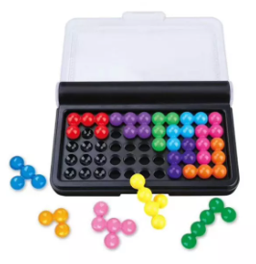
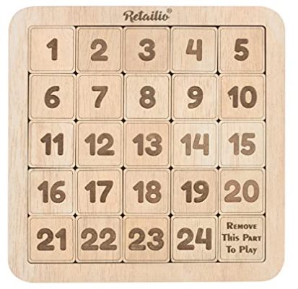
Link to some puzzle games here:
https://studiousguy.com/puzzle-games-for-adults/

Note that you can reuse existing puzzle problems, even reuse their algorithms and some codes, however, you are required to perform at least one of the following:

b.1.1) Data structure modification
Design/Use a set of data structures that are not used in the original solution/code

b.1.2) Algorithm modification
* Design/user a set of algorithms that are not used in the original solution/code
* Your solution must have a time and/or space complexity that is either lower or bigger than that of the original solution/code. Provide a table comparing these complexities between your own solution and the original one.

Always cite and link the resources that are made by others if and when you reuse them in your project. Include those resources and descriptions thereof when you submit your Project Requirement 2

b.2. User interaction and related requirements
The users are required to interact with your program for him/her to make attempts to solve the puzzle. Hence, your program is required to have the following components and operations:

i. Puzzle structure -- your program should maintain a data structure that represents the structure and operations done on the puzzle

ii. Puzzle information – your program should save the latest configuration of the puzzle data incurred from the last action done by the user on the puzzle

iii. In-place solution building – users are provided with all the components of the puzzle during the game. They may be placed on the puzzle board or are viewable on the screen and made available to the user to replace those which are on the board.

There is no need for you to provide the users an aesthetically nice GUI. Simply make sure that the information and controls to play and interact with the game are sufficient for the users.

iv. Invalid configuration attempts – your program should warn and forbid users should their attempted action be an invalid one based on the rules and constraints of your puzzle.

v. Request Puzzle Solution – users can ask the program to solve the puzzle – starting from the latest puzzle information/configuration resulting from the user's interaction with the program.

b.3. Problem resolution
Upon the request of the user, your program should provide a solution to the problem instance. This solution must start at the latest puzzle information/configuration resulting from the user's interaction with the program

B. Project Requirement 2: CMSC 122 Project Presentation
Please submit the following Project Artifacts by the end of Week 17:
- A copy of the algorithm containing the data structures you used in your project.
- A report on the time and space complexity of your algorithm to solve the puzzle.
- A zipped file containing your final software project containing the source code and its deployment(.exe file or URL)
- A zipped copy of your recorded demo videos simulating the test cases in the algorithm

Reminder: Include in your submissions the resources which are made by others and for which you reused and/or modified in your project.

Note: There is no need for a synchronous, online presentation/defense of your CMSC 122 Project. Should your submission of your Project Requirement 2 deem to be insufficient, e.g. your project components are lacking, your teacher may request you to improve your project and do another presentation in the subsequent week with point deductions in place.

Deadlines/Date Dues
- Project Requirement 1: CMSC 122 Project Proposal
  - PR1 - part 1: End of Week 9
  - PR1 - part 2: End of Week 12

- Project Requirement 2: CMSC 122 Project Presentation – End of Week 17

Evaluation Criteria
Your CMSC 122 Project shall be graded using the following criteria:

- Data Structure Design and Management - 30%
This criterion is used to evaluate the appropriateness and completeness of the data structures you are using to solve your problem. Furthermore, it is also used to evaluate the appropriateness and completeness of the inherent operations that are built into managing each of your data structures.

- Algorithm Design and Management - 30%
This criterion is used to evaluate the correctness and completeness of your algorithms at design time as well as their corresponding lines-of-codes in your project.

- Asymptotic Analysis - 10%
This criterion is used to evaluate your correctness and completeness of your asymptotic analysis on space and time utilization of your data structures and algorithms in solving your problem.

- Implementation Artifacts - 30%
This criterion is used to evaluate the correctness and completeness of all your implementation artifacts such as your CMSC 122 Lines-of-Codes, deployment artifacts(e.g. executable files, database/auxiliary storage files(if any), test case datasets, and other referenced materials(i.e. Lines-of-codes you have reused/adopted/extended, etc.).

